Cyber Panic - Requirements

David N. Cole

CST-451 Capstone Project Requirements Document

Grand Canyon University

Instructor: Professor Mark Reha

Revision:

Date: 9/24/2023

**ABSTRACT**

Summarize the entire project in 2-3 paragraphs, about 15-20 lines. The abstract should be enough for one to get an idea of what this project is about, what was the task, and what you accomplished. Briefly provide the broader context. Write this section only after the entire project is complete.

Since the project is a game, it should have a simple to understand rule set but I want the system to have a more complicated undertone. As such, while not the most important, a critical element will be the UI. There will be little navigation beyond logging in and playing a match. The layout may change but the overall image here is two cards in play that can be swapped with one of three from the hand. All of the information the player needs is the software health, shield values, and the cards in play. Actions that cannot be played should be grayed out.

Then when it comes to the mechanics of the game, each player has a deck, which is composed of cards. Each of these cards will have two actions. Then, each of these actions will have one of a variety of effects. At face value, the actions are somewhat simple, but given the variety of effects, some care will need to be taken to ensure they function appropriately. This is being notated as it was an issue with a project some time ago. So, when an action is played, it will need to generate the appropriate effect and appropriately manage the cooldown.

As of now, the enemy AI concept is undeveloped and will simply use a random action within the game scene.

|  |
| --- |
| History and Signoff Sheet |

**Change Record**

|  |  |  |
| --- | --- | --- |
| **Date** | **Author** | **Revision Notes** |
|  |  | Initial draft for review/discussion |
|  |  |  |
|  |  |  |

|  |
| --- |
| **Overall Instructor Feedback/Comments** |

|  |
| --- |
| **Overall Instructor Feedback/Comments** |

**Integrated Instructor Feedback into Project Documentation**

Yes  No

**TABLE OF CONTENTS**

Functional Requirements 4

Non-Functional Requirements 5

Technical Requirements 6

Logical System Design 7

User Interface Design 8

Reports Design 9

Functional Requirements

**User Stories**

|  |  |  |
| --- | --- | --- |
| As a player, I want to use attacks |  |  |
| As a player, I want to heal |  |  |
| As a player, I want to protect my hp |  |  |
| As a player I want to deal with enemy shields |  |  |
| As a player, I want cards to have a cooldown |  |  |
| As a player, I want to have a saved deck |  |  |
| As a player, I want to log in to access my deck |  |  |
| As a player, I want to swap out in-play cards with in-hand cards |  |  |
| As a player, I want multiple actions per turn |  |  |
| As a player, I want an AI combatant |  |  |
| As an AI, I want to make sense |  |  |
| As a player, I want difficulty levels for AI |  |  |
|  |  |  |

***NOTE: If necessary, you may add subsections to those listed in order to match the requirements in the assignment description. Do not remove any top-level sections (those that are listed in the Table of Contents). As required by your project, you may add additional top-level sections (please update the Table of Contents).***

Non-Functional Requirements

**Use Cases**

Describe the sequence of non-functional actions a project performs with either textual Use Cases, UML Use Case diagrams, or if using Scrum, provide a link to the User Stories (see template included in course materials).

NOTE: Once the non-functional requirements have been completed, there may be situations where Use Cases or User Stories may need to be taken out of scope, possibly due to technical challenges or timeline challenges. Any Use Cases or User Stories that are taken out of scope once the project development has started must be approved by the mentor and instructor with justification as to why the functionality is being removed from the project. The following must be updated if any Use Cases or User Stories are taken out of scope:

|  |  |  |
| --- | --- | --- |
| **Use Case or User Story** | **Approval Date** | **Justification** |
| As a player, I want to be able to see what actions an AI takes as it takes them. |  |  |
| As a player, I want art to differentiate my cards |  |  |
| As a player, I want animations to experience the impact of certain actions |  |  |
| As a player, I want sound effects to make the game more engaging |  |  |
| As a player, I want items to affect the game |  |  |
| As a player, I want to create my own deck |  |  |

Technical Requirements

**Use Cases**

Describe the tools and technologies used in the project.

NOTE: Once the technical requirements have been completed, there may be situations where technologies or tools may need to be taken out of scope or changed, possibly due to technical challenges or timeline challenges. Any technologies or tools that are taken out of scope or changed once the project development has started must be approved by the mentor and instructor with justification as to why the functionality is being removed from the project. The following must be updated if any technologies or tools are taken out of scope or changed:

|  |  |  |
| --- | --- | --- |
| **Technology or Tool** | **Approval Date** | **Justification** |
| **C# IDE (Rider/VS)** |  |  |
| **MySQL Database** |  |  |
| **MAMP** |  |  |

Logical System Design

Provide a diagram of the logical architecture of the system.

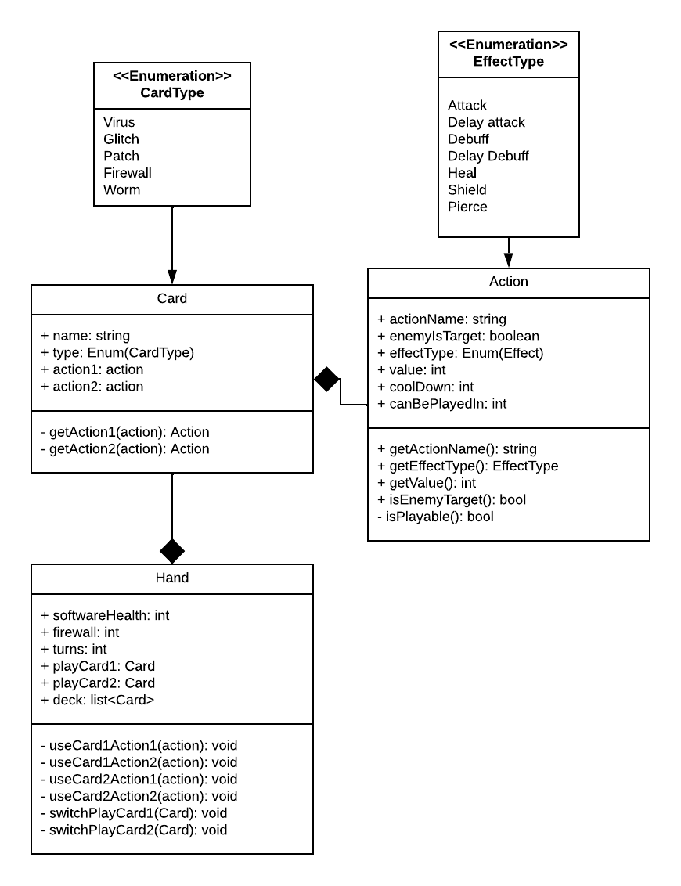

User Interface Design

Provide a sitemap and user interface design diagram for each user interface screen in the application, if not applicable, define the components of the project as described in the handbook.

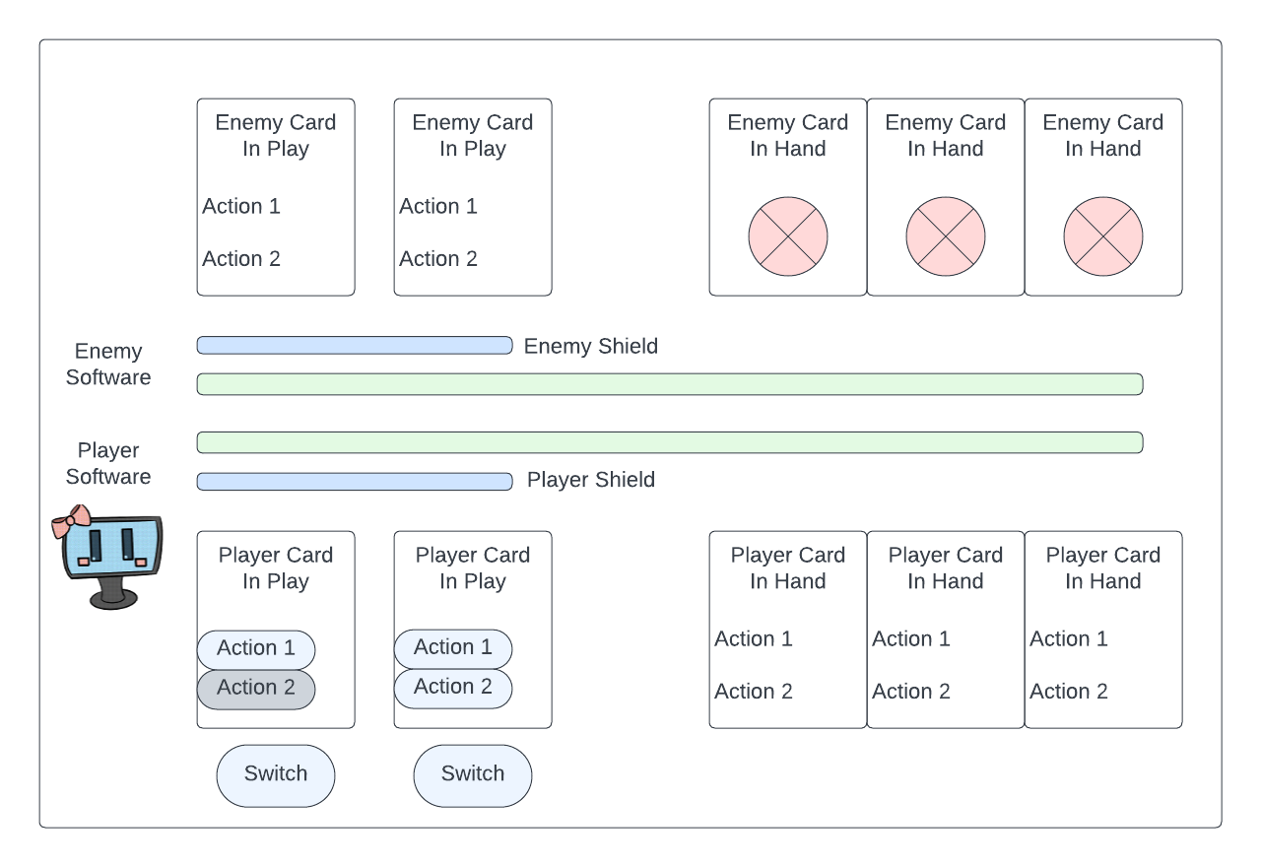

Source: Software Icon courtesy of my fiancée

Reports Design

The game does not provide any reports.